**Weather Website**

**Project Report**

**Group Members:**

21k-3062 Hairam Naseem

21k-3010 Huzaifa Zulfiqar

21k-3066 Omer Shoaib

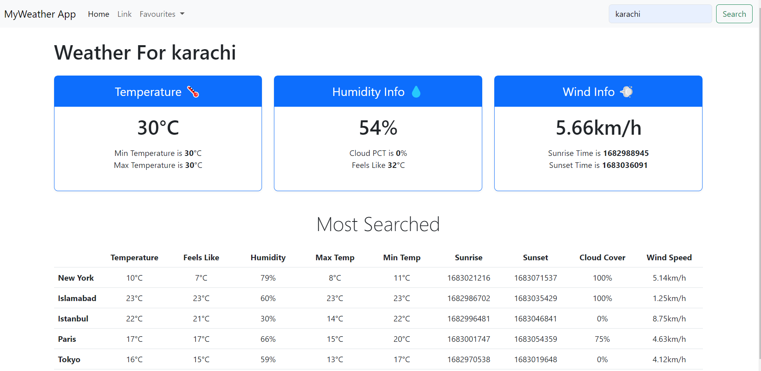

**Index**

**Topics Page Number**

Features 3

Model and Method used 4

Tools and Technologies Used 4

Functional Requirements 5

Non-Functional Requirements 5

WBS Structure 6,7

Test Cases 8

Verification and Validation 9

Task Distribution 9

Gantt Chart 10

**Features:**

1. Real-time weather updates: The website fetches real-time weather data using an API and displays the weather information for the entered city.
2. Multiple city weather information: The website can display the weather information for multiple cities at the same time.
3. User input: The website allows users to input the name of the city for which they want to get weather information.
4. Interactive UI: The website has a user-friendly interface that allows users to easily interact with the application and view weather information.
5. Error handling: The website provides error handling in case there is an issue with the API or the user enters an invalid city name.
6. Cloud percentage: The website displays the percentage of cloud cover in addition to other weather parameters.
7. Responsive design: The website is designed to work on multiple screen sizes and devices.
8. API integration: The website integrates with a third-party API to get real-time weather data.
9. Data processing: The website processes the received data and displays it in a structured and organized manner.

**Model and Method used for the website:**

We have used **Agile** method for development of the weather website which is a set of software development practices that prioritize iterative development and frequent feedback from stakeholders. Some benefits of using agile method while building a weather website are:

1. To prioritise features based on user demands: agile approaches involve extensive collaboration with all stakeholders, including end users, to comprehend their needs. This can assist developers in setting priorities for the user-valued services, such as precise weather information, interactive maps, and tailored notifications.
2. Continuous delivery: Agile methodologies place a strong emphasis on producing usable software in brief iterations, frequently every week or every two weeks. Due to new weather events or developing technologies, this can assist weather websites adapt fast to changing customer needs and market conditions.
3. Iterative Development: Agile approaches encourage iterative development, which entails breaking down large development projects into smaller, more manageable jobs that may be finished quickly. Teams working on the creation of weather websites can utilise this to test new features, discover problems fast, and incorporate user feedback.
4. Collaborative Development: Agile methodologies encourage collaboration between development teams, stakeholders, and users. Teams creating weather websites may find it easier to collaborate, share knowledge, and acquire a sense of responsibility for the finished project as a result.

**Tools and Technologies used:**

The website is built on HTML and JavaScript on the IDE Visual Studio Code.

**Functional requirements:**

1. Display weather information: The application should display weather information for a specific city, including temperature, minimum and maximum temperature, humidity, cloud percentage, wind speed, sunrise time, and sunset time.
2. Search for cities: The user should be able to search for weather information for a specific city by entering the city name in the search bar.
3. Add to favourites: The user should be able to add a city to their favourites list. The application should allow the user to enter the name of the city to add and display a list of the user's favourite cities.
4. Responsive design: The application should be responsive and display properly on different screen sizes and devices.
5. Use of third-party APIs: The application should use third-party APIs to retrieve weather data for the specified city and display it on the application.
6. User-friendly interface: The application should have a user-friendly interface, with clear navigation and easy-to-understand icons and labels.

**Non-functional Requirements:**

1. Usability: The website should be easy to navigate and use for users of all levels of technical proficiency.
2. Performance: The website should load quickly and be able to handle a high volume of traffic without crashing.
3. Reliability: The website should be always available and accessible to users, with minimal downtime or maintenance windows.
4. Security: The website should be secure and protect user information and data from unauthorized access.
5. Compatibility: The website should be compatible with a wide range of devices and web browsers.
6. Accessibility: The website should be designed to be accessible to users with disabilities, such as visual impairments.
7. Scalability: The website should be designed to accommodate future growth and changes in technology.
8. Accuracy: The website should provide accurate and up-to-date weather information.
9. Availability: The website should be available 24/7 and should provide weather information for a wide range of locations.
10. Personalization: The website should be able to personalize the user experience based on their location and preferences.

**WBS Structure:**

1. Planning and Analysis

* Project Management
* Requirements Gathering
* Feasibility Analysis
* User Research
* Information Architecture

1. Design

* User Interface Design
* Visual Design
* Interaction Design
* Information Design

1. Development

* Front-End Development
* Back-End Development
* Database Design and Management
* APIs Integration

1. Testing

* System Testing
* Integration Testing
* User Acceptance Testing

1. Deployment

* Hosting Configuration
* Production Deployment
* Backup and Recovery

1. Maintenance and Support

* Bug Fixes
* Upgrades and Enhancements
* User Support
* Server Maintenance and Monitoring

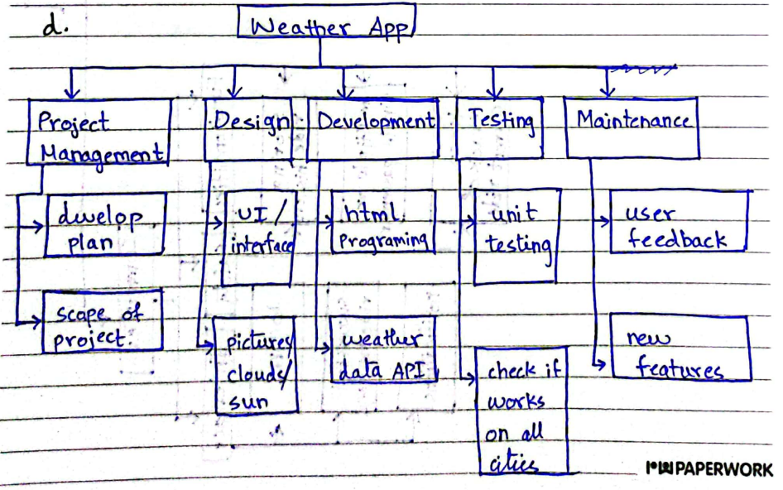

**Test Cases for the website:**

1. Test Case: Search for a valid city

Input: Enter "New York" in the search box and click on the "Search" button

Output: The weather information for New York should be displayed in the three cards

1. Test Case: Search for an invalid city

Input: Enter "abcdefgh" in the search box and click on the "Search" button

Output: An error message should be displayed indicating that the city could not be found

1. Test Case: Add a city to favourites.

Input: Click on the "Favourites" dropdown menu and enter "San Francisco" in the input field and click on "Add"

Output: The city "San Francisco" should be added to the favourites list displayed in the dropdown menu

1. Test Case: View weather information for a city in favourites

Input: Click on a city name in the favourites list displayed in the dropdown menu

Output: The weather information for the selected city should be displayed in the three cards

1. Test Case: Invalid input for adding a city to favourites.

Input: Click on the "Favourites" dropdown menu and enter an empty string in the input field and click on "Add"

Output: An error message should be displayed indicating that a city name is required to add to favourites

1. Test Case: Responsive design

Input: Resize the browser window to different screen sizes

Output: The website layout should adjust to different screen sizes and be responsive

**Verification and Validation:**

Verification is the process of ensuring that the software meets its specified requirements and that it functions correctly. In the case of our weather website, some verification activities include:

1. Checking that the website displays accurate weather information.
2. Checking that the website is accessible on different browsers.
3. Checking that the website is secure and does not allow unauthorized access to user data.
4. Checking that the website is responsive and performs well under different network conditions.

Validation is the process of ensuring that the software meets the needs of the user and that it is fit for purpose. In our weather website, some of the validation activities include:

1. Conducting user surveys to gather feedback on the website's functionality and ease of use.
2. Conducting user testing to identify any usability issues with the website.
3. Checking that the website meets any relevant industry standards and regulations.
4. Checking that the website provides accurate and useful weather information to its users.

Overall, both verification and validation are important processes in ensuring that the weather website meets its intended requirements and provides value to its users.

**Task Distribution:**

Hairam: idea and Report

Huzaifa: layout and Favourites option

Omer: Most Searches option

**Gantt Chart:**

